CEMENT Primary Survey
Section 1 contains the agreement between the University and the survey respondent.

This study is being conducted as part of the Australian Learning and Teaching Council (ALTC) project (PP10- 1638) titled Building the Culture of Evidence-based Practice in Teacher Preparation for Mathematics Teaching. Details about the project were provided to you in the email that contained the link to this survey. Please read the statements below and then click on the appropriate button.

Clicking on ‘I agree’ implies consent to participate in this study.

1. I have read and understood the 'Information Sheet' for this project which was emailed to me.
2. The nature and possible effects of the study have been explained to me in the email information sheet.
3. I understand that the study involves completing this survey which will take no more than one hour.
4. I understand that participation involves no particular risk.
5. I understand that all research data will be securely stored on the University of Tasmania premises for at least five years, and will then be destroyed.
6. Any questions that I have asked have been answered to my satisfaction.
7. I agree that research data gathered from me for the study may be published provided that I cannot be identified as a participant.
8. I understand that the researchers will maintain my identity confidential and that any information I supply to the researcher(s) will be used only for the purposes of the research.
9. I agree to participate in this investigation and understand that I may withdraw at any time without any effect, and if I so wish, may request that any data I have supplied to date be withdrawn from the research.

Support for this activity has been provided by the Australian Learning and Teaching Council Ltd, an initiative of the Australian Government Department of Education, Employment and Workplace Relations. The views expressed in this activity do not necessarily reflect the views of the Australian Learning and Teaching Council.

☐ I Agree
☐ I Disagree

Section 2 of the survey asks for information on what institution the student is studying at, what courses, previous highest educational level attained, highest level of mathematics or statistics completed previous to the current degree, mode of study (internal/external; full-time/part-time), planned year of completion, country of previous education, Aboriginal/Torres Strait Islander status, and English language status.

Section 3 is a block of 19 questions that appear in random order. Not all questions are presented in every survey instance.

The following questions are about your general views of mathematics and mathematics learning and teaching. Please select the option that best describes your views.
 | Strongly Disagree | Disagree | Neither Agree nor Disagree | Agree | Strongly Agree
Mathematics is a beautiful and creative human endeavour.
Periods of uncertainty and confusion are important for mathematics learning.
Acknowledging multiple ways of mathematical thinking may confuse children.
Mathematical ideas exist independently of human ability to discover them.
Students learn by practicing procedures and methods for performing mathematical tasks.
Teachers must be able to represent mathematical ideas in a variety of ways.
The procedures and methods used in mathematics guarantee right answers.
Justifying mathematical thinking is an important part of learning mathematics.
The teacher must be receptive to the students' suggestions and ideas.

 | Not at all confident | A little confident | Don’t know | Fairly confident | Completely confident
Please rate your confidence to teach mathematics at the grade levels that you will be qualified to teach on the following scale.

 | Always True | Sometimes true | Never true
The product of an odd number and an even number is odd.

 | None | Ten | One hundred | Infinitely Many
How many different numbers are there between 0.7 and 0.8?

Which diagram does NOT have 3⁄4 of the area shaded?

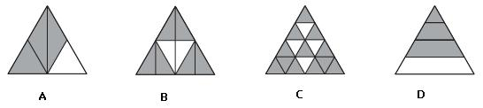

 | 8.5% | 25% | 30% | 42.5%
Twelve (12) chips are labelled 2, 3, 5, 6, 8, 10, 11, 12, 14, 15, 18 and 20 respectively. The twelve chips are placed in a bag and one is drawn out at random. What is the probability that the number on the chip is both even and a multiple of 3?

 | 5.8m | 6m | 9m | 10.8m
An upright 1-metre stick casts a shadow that is 60 centimetres long. At the same time, a flagpole casts a shadow that is 5.4 metres long. How high is the flagpole?

Below are two currency conversion graphs.
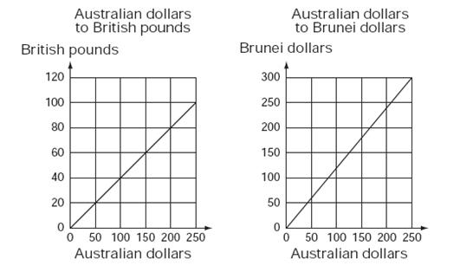
 | 20 | 50 | 125 | 150
How many Brunei dollars are equal in value to 50 British pounds?

 | 12.5% | 15% | 17.5% | 23.5% | 25%
Steve buys a shirt that is discounted by 10% on the ticket. A sign on the rack stated, ‘Discount by a further 15%’. This is the same as a discount of what percentage of the original price of the shirt?

 | 7 | 8 | 10 | 12
A set menu has a choice of 3 entrées, 2 mains and 2 desserts. A person chooses a meal that has one entrée, one main and one dessert.
How many different meal combinations are possible?

A model of how a shell grows can be made using enlarged copies of the same triangle. Here is a picture of a model. Here is a picture of a model.
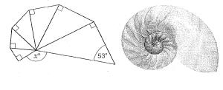
 | 127 | 138 | 143 | 153 | 222
What is the value of x in degrees?

A broken ruler, marked in centimetres, is being used to measure the length of a black bar as shown in the diagram below. What is the length of the black bar in centimetres? Be as accurate as possible. Type the number of centimetres in the box (do not include the units).
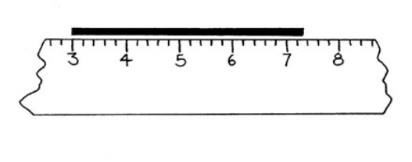

 | 3 , 3 , 3  6 5 4 | 3 , 19 , 5  4 24 6 | 4 , 5 , 6  5 6 7 | 3 , 19 , 7  4 24 8
Which one of the following contains a set of three fractions that are evenly spaced on a number line?

Your class is exploring measurement concepts. Students make the following statements. Which one of these most urgently requires teacher intervention?
☐ Area is the space inside a shape.
☐ As the perimeter increases, the area always increases.
☐ Volume is the amount of space a shape takes up.
☐ Area is a measurement of the surface.

 | 307 | 316 | 370 | 614
Jane played 10 computer games. Her average score was 304. After her 11th game, her average was 310.
What was Jane's score in her 11th game?

A table can seat eight people: three on each side and one on each end. When tables are put together, more people can be seated (as shown here).
 | t = 6 x p + 2 | 8 x p = t | p = 6 x t + 2 | t = 7 x p + 1
Which of the following best describes the number of people (p) that can be seated at any number of tables (t)?

Indicate whether each of the following statements is True or False. | True | False
A transformation is defined as a slide from one position to another without turning.
Two shapes are congruent if they differ only in position and orientation in space.
An enlargement with a scale factor of 2 doubles the area of a shape.
If two shapes are similar then one is a scaled version of the other.
An enlargement with a scale factor of 1 doubles the lengths of the sides of the shape.

 | 5(x + 7) = 52 | 5x + 7 = 52 | 7x + 5 = 52 | 7(x + 5) = 52 | x = 52 x 5 + 7
I think of a number, multiply it by 5 and add 7 to get an answer of 52. If my number was x, what equation represents this?

Classify each of the following as Never True, Sometimes True or Always True where a and b are real numbers.
 | Never True | Sometimes True | Always True
a x b = b x a
a ÷ b = b ÷ a
5 + a > a
6 ÷ a > a
a² < a
a² +b² =(a + b)²
a - b = b - a

A parallelogram is a quadrilateral for which pairs of opposite sides are parallel. For each of the following shapes mark "True" if it is a parallelogram or "False" if it is not a parallelogram. | True | False
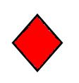
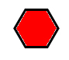
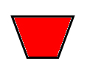
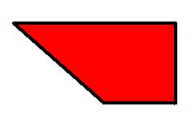

A target is made from 5 squares the same size, as shown.
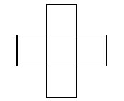
 | 48 | 60 | 80 | 96 | 240
The perimeter of the cross is 48m. What area in square metres (m²) is covered by the cross?

A tiler drew some patterns of white and coloured tiles to fill a square space and put the information in a table.
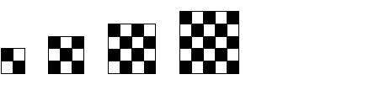
Side length of square space (Tiles) | Total number of white tiles
2 | 2
3 | 4
4 | 8
5 | 12
 |  | 250 | 1200 | 1250 | 2500
How many white tiles would be needed for a square space with a side length of 50 tiles?

Section 4 is a block of 14 questions that appear in random order. Not all questions are presented in every survey instance.

Students were asked to respond to the following question:
A box contains 18 red jubes, 10 green jubes, 10 yellow jubes and 2 black jubes. Without looking, Sheryl takes a jube from the box. What is the chance that the jube is green?

One student says that the chance is 1 in 4. To help interpret this response, which of the following is the most appropriate question to ask next?

☐ It's not clear what they think, so I'd ask them a similar question, but with only 8 red jubes instead of 18 red jubes.
☐ It's not clear what they think, so I'd ask them a similar question with smaller numbers such as: 10 red jubes, 5 green jubes, 4 yellow jubes and 1 black jube.
☐ It's not clear what they think, so I'd ask them a similar question with smaller numbers and fewer categories such as: 7 red jubes, 5 green jubes, and 3 yellow jubes.
☐ Since the student has responded correctly, it is not necessary to do anything more.
When asked to measure the angle below with a protractor, Kylie answers that it is 30°. She asks you if she is correct. For each of the following statements, indicate if you would definitely say it to Kylie, might say it to Kylie, or definitely not say it to Kylie.
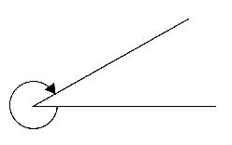
 | Definitely WOULD NOT say | Might Say | WOULD definitely say
Did you measure the amount of space between the lines?
Well done, Kylie, you’re absolutely correct.
Make sure you line up the protractor correctly.
Remember that angles are about the amount of turn, and the arrow shows the direction of turn.
You need to subtract that from 360°.
This one’s tricky because your protractor will only measure angles up to 180°
Can you show me which angle you are trying to measure?

A Year 5 teacher asked her students to determine the value of the following calculation on their calculators:
2 + 3 x 4 =

The class was surprised to find that some student calculators gave a result of 14, while others gave a result of 20. Which of the following best matches your likely response to this situation?

☐ Use the difference as a motivation to teach the students how to use correct order of operations, highlighting an acronym such as BODMAS.
☐ Show the students how to use parentheses or brackets when entering expressions into their calculators.
☐ Check school booklists and supplies to make sure that only one kind of calculator was available to students in the class.
☐ Ask the students to explain the different results, and use their explanations to discuss the order of operations as an arbitrary convention.

A teacher sets the following proportional reasoning task for an upper primary class:

Bill and Ben were out on a Sunday morning bike ride. After three quarters of an hour they passed a sign that showed they had ridden 15 kilometres since they left home and that they still had 25 kilometres to reach their destination. How long will it take them to get there?

Which of the following representations is most helpful for the teacher to develop the students’ understanding of proportional reasoning in solving this problem?

☐ Cross multiplying

☐ Double number line

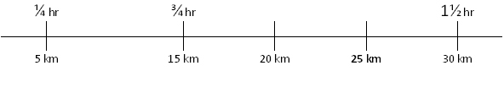

☐ Ratio table

Time | ¾ hr | ¼ hr | 1 hr
Distance | 15 km | 5 km |  | 1 km | 25 km

☐ Find the unit rate:
Riding 15 km in ¾ hr is equivalent to riding 1 km in ¾ ÷ 15 hr.

A 270 g packet of chocolate says “35% more chocolate for free”. What is the best way to use this with an upper primary class to develop their mathematical understanding?
☐ As a starter for a research project about the use of maths in advertising.
☐ I could get students to calculate 35% of 270 g.
☐ As a starter to discuss percentage increase.
☐ I wouldn’t use it – the numbers are too hard.

Ann and Bob are Year 6 students completing a task in which they are asked to investigate the areas of rectangles with a perimeter of 24 cm. Ann claims that the maximum area is 36 cm2, while Bob claims that it is 35 cm2. Which of the following is the most likely explanation of why one of them is incorrect.
☐ Ask the student to measure again and be more careful.
☐ Tell the student that 7 popsticks is “close enough”.
☐ Show me how much of the popstick you would need to fill the missing part.
☐ Tell the student to use something smaller like unifix cubes to fill in the missing part.
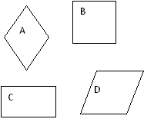
Tommy is in Year 5. He states that A is the only rhombus because it's a diamond.
What might you do to help Tommy develop his understanding of shapes?
 | WOULD NOT do | Might do | WOULD definitely do
Tell Tommy that only A and D are rhombuses
Tell Tommy that D is also a rhombus as it looks like a square that has been rhommed by a bus.
Ask Tommy to turn all the shapes into the same orientation as A.
Ask Tommy to measure the sides of each shape.
Tell Tommy that he's correct.

Penny is a Year 4 student who is attempting to use a subtraction algorithm. In the following example of her work, something is incorrect.

What would you do to help Penny understand how to use this algorithm?
 | WOULD NOT do | Might do | WOULD definitely do
Show her how to do the algorithm, then let Penny do another one.
Get her to use the algorithm to calculate 709 - 84.
Give her a calculator to check her answer.
Get her to calculate 797 - 84.
Use multibase arithmetic blocks (MAB) to demonstrate the process.
Suggest using an empty number line.

A student says that 1/4 + 1/4 is 2/8. She uses counters to show this as follows:

Given what the student has just shown you, which of the following representations of 1/4 + 1/4 is most likely to help her to see that 1/4 + 1/4 = 1/2?

☐
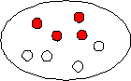

☐
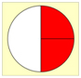

☐
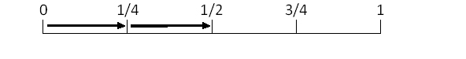

☐

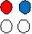

☐
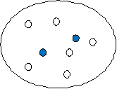

An important skill for young children to have is the ability to instantly see how many objects are in a small group, otherwise known as 'subitising'. Which of these is the most appropriate materials to use when helping students develop these skills?

☐ A number line
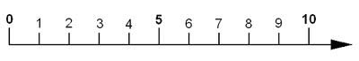
☐ Dominoes and dice
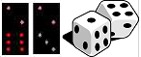

☐ Numeral Expander
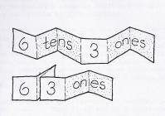
☐ Multi Base Arithmetic Block (MAB or Dienes' Blocks)
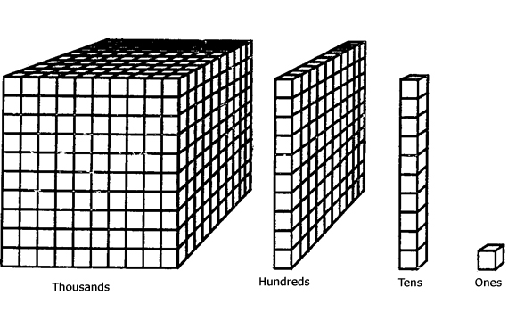
☐ A large collection of similar objects
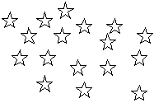

When asked to describe how they determined

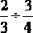

a student wrote the following on the classroom whiteboard:

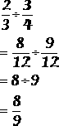

How would you respond to this?

☐ Remind them that it is only necessary to find a common denominator when doing addition and subtraction.
☐ Let them know that this method will work only sometimes and that to divide fractions they should instead invert the second fraction and then multiply.
☐ Explain that the twelves can be cancelled out only when there is one on the numerator and one on the denominator.
☐ Reassure them that this procedure is acceptable, but ask them to explain their thinking to other students.

Which of the following explanations is least likely to be helpful in assisting a student who is struggling to understand that 1.26 is greater than 1.026?

☐ Multiplying both numbers by 1000 gives us 1260 and 1026.
1260 is greater than 1026 so 1.26 is greater than 1.026.

☐ 1.26 is 1 whole + 2 tenths + 6 hundredths
1.026 is 1 whole + 0 tenths + 2 hundredths + 6 thousandths

☐ It’s easier to compare decimals that are the same length and we can add zeros to the end of a decimal without changing it, so, 1.26 is the same as 1.260. We can now see that 1.26 is greater than 1.026 because 260 is greater than 026 (which is 26).

☐
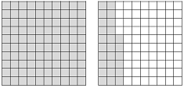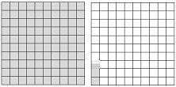
1.26 1.026

Section 4 of the survey asks participants whether they are willing to be interviewed, provides an opportunity for participants to go back over questions, and to provide their details if they would like an entry to win an iPod Touch.

