CEMENT Secondary Survey
Section 1 contains the agreement between the University and the survey respondent.

This study is being conducted as part of the Australian Learning and Teaching Council (ALTC) project (PP10- 1638) titled Building the Culture of Evidence-based Practice in Teacher Preparation for Mathematics Teaching. Details about the project were provided to you in the email that contained the link to this survey. Please read the statements below and then click on the appropriate button.

Clicking on ‘I agree’ implies consent to participate in this study.

1. I have read and understood the 'Information Sheet' for this project which was emailed to me.
2. The nature and possible effects of the study have been explained to me in the email information sheet.
3. I understand that the study involves completing this survey which will take no more than one hour.
4. I understand that participation involves no particular risk.
5. I understand that all research data will be securely stored on the University of Tasmania premises for at least five years, and will then be destroyed.
6. Any questions that I have asked have been answered to my satisfaction.
7. I agree that research data gathered from me for the study may be published provided that I cannot be identified as a participant.
8. I understand that the researchers will maintain my identity confidential and that any information I supply to the researcher(s) will be used only for the purposes of the research.
9. I agree to participate in this investigation and understand that I may withdraw at any time without any effect, and if I so wish, may request that any data I have supplied to date be withdrawn from the research.

Support for this activity has been provided by the Australian Learning and Teaching Council Ltd, an initiative of the Australian Government Department of Education, Employment and Workplace Relations. The views expressed in this activity do not necessarily reflect the views of the Australian Learning and Teaching Council.

☐ I Agree

☐ I Disagree

Section 2 of the survey asks for information on what institution the student is studying at, what courses, previous highest educational level attained, highest level of mathematics or statistics completed previous to the current degree, mode of study (internal/external; full-time/part-time), planned year of completion, country of previous education, Aboriginal/Torres Strait Islander status, and English language status.

Section 3 is a block of 10 questions.

The following questions are about your general views of mathematics and mathematics learning and teaching. Please select the option that best describes your views.
 | Strongly Disagree | Disagree | Neither Agree nor Disagree | Agree | Strongly Agree
Mathematics is a beautiful and creative human endeavour.
Periods of uncertainty and confusion are important for mathematics learning.
Acknowledging multiple ways of mathematical thinking may confuse children.
Mathematical ideas exist independently of human ability to discover them.
Students learn by practicing procedures and methods for performing mathematical tasks.
Teachers must be able to represent mathematical ideas in a variety of ways.
The procedures and methods used in mathematics guarantee right answers.
Justifying mathematical thinking is an important part of learning mathematics.
The teacher must be receptive to the students' suggestions and ideas.

 | Not at all confident | A little confident | Don’t know | Fairly confident | Completely confident
Please rate your confidence to teach mathematics at the grade levels that you will be qualified to teach on the following scale.

Section 4 is a block of 21 questions that appear in random order. Not all questions are presented in every survey instance.

 | Always True | Sometimes true | Never true
The product of an odd number and an even number is odd.

 | None | Ten | One hundred | Infinitely Many
How many different numbers are there between 0.7 and 0.8?

A parallelogram is a quadrilateral having pairs of opposite sides parallel. Decide whether the following statements are "Always true", "Sometimes true" or "Never true" for parallelograms.
 | Never True | Sometimes True | Always True
Has pairs of opposite sides of equal length
Has rotational symmetry
Has two lines of reflection or mirror symmetry
Has all 4 angles equal.
Has pairs of adjacent angles that add up to 180°
Has pairs of opposite angles equal
Is a regular shape.
Has equal diagonals
Has diagonals that cross at right angles when adjacent angles are different

Which diagram does NOT have 3⁄4 of the area shaded?

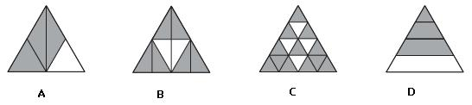

 | 2, 3, 5 | 1, 2, 3, 5 | 2, 3, 5, 6, 10, 15, 30 | 1, 2, 3, 5, 6, 10, 15, 30
What are the prime factors of 30?

 | 8.5% | 25% | 30% | 42.5%
Twelve (12) chips are labelled 2, 3, 5, 6, 8, 10, 11, 12, 14, 15, 18 and 20 respectively. The twelve chips are placed in a bag and one is drawn out at random. What is the probability that the number on the chip is both even and a multiple of 3?

 | 5.8m | 6m | 9m | 10.8m
An upright 1-metre stick casts a shadow that is 60 centimetres long. At the same time, a flagpole casts a shadow that is 5.4 metres long. How high is the flagpole?

 | 12.5% | 15% | 17.5% | 23.5% | 25%
Steve buys a shirt that is discounted by 10% on the ticket. A sign on the rack stated, ‘Discount by a further 15%’. This is the same as a discount of what percentage of the original price of the shirt?

Below are two currency conversion graphs.
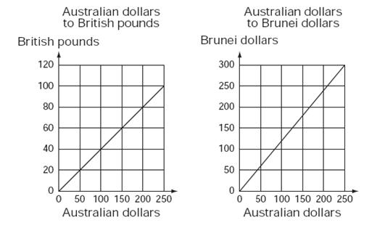
 | 20 | 50 | 125 | 150
How many Brunei dollars are equal in value to 50 British pounds?

A model of how a shell grows can be made using enlarged copies of the same triangle. Here is a picture of a model. Here is a picture of a model.
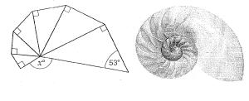
 | 127 | 138 | 143 | 153 | 222
What is the value of x in degrees?

A table can seat eight people: three on each side and one on each end. When tables are put together, more people can be seated (as shown here).
 | t = 6 x p + 2 | 8 x p = t | p = 6 x t + 2 | t = 7 x p + 1
Which of the following best describes the number of people (p) that can be seated at any number of tables (t)?

A broken ruler, marked in centimetres, is being used to measure the length of a black bar as shown in the diagram below. What is the length of the black bar in centimetres? Be as accurate as possible. Type the number of centimetres in the box (do not include the units).
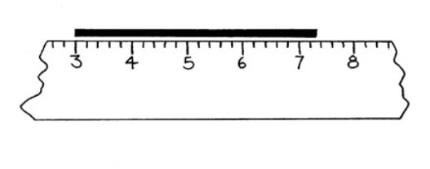

 | 3 , 3 , 3  6 5 4 | 3 , 19 , 5  4 24 6 | 4 , 5 , 6  5 6 7 | 3 , 19 , 7  4 24 8
Which one of the following contains a set of three fractions that are evenly spaced on a number line?

 | 7 | 8 | 10 | 12
A set menu has a choice of 3 entrées, 2 mains and 2 desserts. A person chooses a meal that has one entrée, one main and one dessert.
How many different meal combinations are possible?

Indicate whether each of the following statements is True or False. | True | False
A transformation is defined as a slide from one position to another without turning.
Two shapes are congruent if they differ only in position and orientation in space.
An enlargement with a scale factor of 2 doubles the area of a shape.
If two shapes are similar then one is a scaled version of the other.
An enlargement with a scale factor of 1 doubles the lengths of the sides of the shape.

Classify each of the following as Never True, Sometimes True or Always True where a and b are real numbers.
 | Never True | Sometimes True | Always True
a x b = b x a
a ÷ b = b ÷ a
5 + a > a
6 ÷ a > a
a² < a
a² +b² =(a + b)²
a - b = b - a

A parallelogram is a quadrilateral for which pairs of opposite sides are parallel. For each of the following shapes mark "True" if it is a parallelogram or "False" if it is not a parallelogram. | True | False
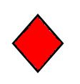
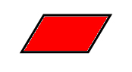
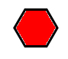
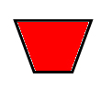
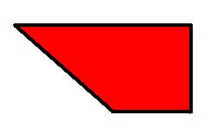

 | 5(x + 7) = 52 | 5x + 7 = 52 | 7x + 5 = 52 | 7(x + 5) = 52 | x = 52 x 5 + 7
I think of a number, multiply it by 5 and add 7 to get an answer of 52. If my number was x, what equation represents this?

 | 307 | 316 | 370 | 614
Jane played 10 computer games. Her average score was 304. After her 11th game, her average was 310.
What was Jane's score in her 11th game?

A target is made from 5 squares the same size, as shown.
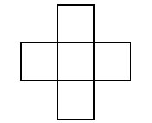
 | 48 | 60 | 80 | 96 | 240
The perimeter of the cross is 48m. What area in square metres (m²) is covered by the cross?

A tiler drew some patterns of white and coloured tiles to fill a square space and put the information in a table.
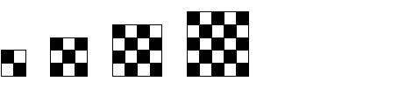
Side length of square space (Tiles) | Total number of white tiles
2 | 2
3 | 4
4 | 8
5 | 12
 |  | 250 | 1200 | 1250 | 2500
How many white tiles would be needed for a square space with a side length of 50 tiles?

Section 5 is a block of 15 questions that appear in random order. Not all questions are presented in every survey instance.
Students were asked to respond to the following question:
A box contains 18 red jubes, 10 green jubes, 10 yellow jubes and 2 black jubes. Without looking, Sheryl takes a jube from the box. What is the chance that the jube is green?

One student says that the chance is 1 in 4. To help interpret this response, which of the following is the most appropriate question to ask next?

☐ It's not clear what they think, so I'd ask them a similar question, but with only 8 red jubes instead of 18 red jubes.
☐ It's not clear what they think, so I'd ask them a similar question with smaller numbers such as: 10 red jubes, 5 green jubes, 4 yellow jubes and 1 black jube.
☐ It's not clear what they think, so I'd ask them a similar question with smaller numbers and fewer categories such as: 7 red jubes, 5 green jubes, and 3 yellow jubes.
☐ Since the student has responded correctly, it is not necessary to do anything more.

When asked to measure the angle below with a protractor, Kylie answers that it is 30°. She asks you if she is correct. For each of the following statements, indicate if you would definitely say it to Kylie, might say it to Kylie, or definitely not say it to Kylie.
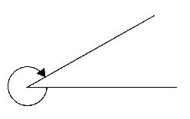
 | Definitely WOULD NOT say | Might Say | WOULD definitely say
Did you measure the amount of space between the lines?
Well done, Kylie, you’re absolutely correct.
Make sure you line up the protractor correctly.
Remember that angles are about the amount of turn, and the arrow shows the direction of turn.
You need to subtract that from 360°.
This one’s tricky because your protractor will only measure angles up to 180°
Can you show me which angle you are trying to measure?

A class of Year 2 students is using popsticks to measure the width of a desk. A student measures the width to be more than 7 popsticks, but less than 8. He asks if he can break a popstick to fill the missing part. What would you do to continue the learning created through the use of this task?
☐ Ask the student to measure again and be more careful.
☐ Tell the student that 7 popsticks is “close enough”.
☐ Show me how much of the popstick you would need to fill the missing part.
☐ Tell the student to use something smaller like unifix cubes to fill in the missing part.

A teacher sets the following proportional reasoning task for an upper primary class:

Bill and Ben were out on a Sunday morning bike ride. After three quarters of an hour they passed a sign that showed they had ridden 15 kilometres since they left home and that they still had 25 kilometres to reach their destination. How long will it take them to get there?

Which of the following representations is most helpful for the teacher to develop the students’ understanding of proportional reasoning in solving this problem?

☐ Cross multiplying

☐ Double number line

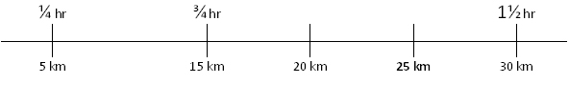

☐ Ratio table

Time | ¾ hr | ¼ hr | 1 hr
Distance | 15 km | 5 km |  | 1 km | 25 km

☐ Find the unit rate:
Riding 15 km in ¾ hr is equivalent to riding 1 km in ¾ ÷ 15 hr.

A Year 5 teacher asked her students to determine the value of the following calculation on their calculators:
2 + 3 x 4 =

The class was surprised to find that some student calculators gave a result of 14, while others gave a result of 20. Which of the following best matches your likely response to this situation?

☐ Use the difference as a motivation to teach the students how to use correct order of operations, highlighting an acronym such as BODMAS.
☐ Show the students how to use parentheses or brackets when entering expressions into their calculators.
☐ Check school booklists and supplies to make sure that only one kind of calculator was available to students in the class.
☐ Ask the students to explain the different results, and use their explanations to discuss the order of operations as an arbitrary convention.
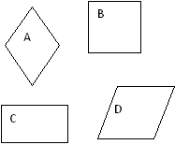
Tommy is in Year 5. He states that A is the only rhombus because it's a diamond.
What might you do to help Tommy develop his understanding of shapes?
 | WOULD NOT do | Might do | WOULD definitely do
Tell Tommy that only A and D are rhombuses
Tell Tommy that D is also a rhombus as it looks like a square that has been rhommed by a bus.
Ask Tommy to turn all the shapes into the same orientation as A.
Ask Tommy to measure the sides of each shape.
Tell Tommy that he's correct.

You ask your students to write down everything they know about triangles. A group of students mention side and angle properties, but do not include any symmetrical properties. You decide to explore symmetry with the students. Indicate which of the following shapes are symmetrical as well as whether the shape is useful when teaching symmetry.
 | The line shows an axis of symmetry |  | The shape is useful for teaching symmetry
 | Yes | No | Yes | No
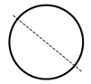
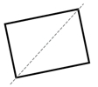
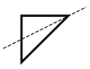
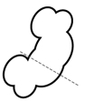
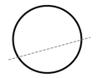
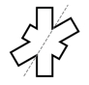
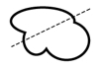
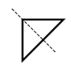
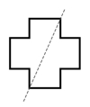

A student says that 1/4 + 1/4 is 2/8. She uses counters to show this as follows:

Given what the student has just shown you, which of the following representations of 1/4 + 1/4 is most likely to help her to see that 1/4 + 1/4 = 1/2?

☐
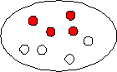

☐
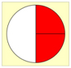

☐
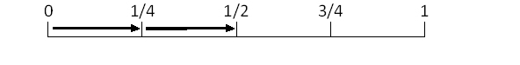

☐

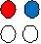

☐
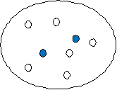

Your class is exploring measurement concepts. Students make the following statements. Which one of these most urgently requires teacher intervention?
☐ Area is the space inside a shape.
☐ As the perimeter increases, the area always increases.
☐ Volume is the amount of space a shape takes up.
☐ Area is a measurement of the surface.

When asked to describe how they determined

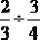

a student wrote the following on the classroom whiteboard:

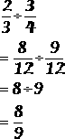

How would you respond to this?

☐ Remind them that it is only necessary to find a common denominator when doing addition and subtraction.
☐ Let them know that this method will work only sometimes and that to divide fractions they should instead invert the second fraction and then multiply.
☐ Explain that the twelves can be cancelled out only when there is one on the numerator and one on the denominator.
☐ Reassure them that this procedure is acceptable, but ask them to explain their thinking to other students.

Ann and Bob are Year 6 students completing a task in which they are asked to investigate the areas of rectangles with a perimeter of 24 cm. Ann claims that the maximum area is 36 cm2, while Bob claims that it is 35 cm2. Which of the following is the most likely explanation of why one of them is incorrect.
☐ Ann is incorrect because she has not understood the difference between a square and a rectangle.
☐ Ann is incorrect because she has calculated 5.9 by 6.1 and rounded up.
☐ Bob is incorrect because he thinks squares are not rectangles.
☐ Bob is incorrect because he has only used whole numbers instead of decimals.

An important skill for young children to have is the ability to instantly see how many objects are in a small group, otherwise known as 'subitising'. Which of these is the most appropriate materials to use when helping students develop these skills?
☐ A number line
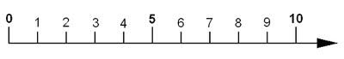
☐ Dominoes and dice
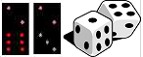

☐ Numeral Expander
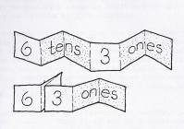
☐ Multi Base Arithmetic Block (MAB or Dienes' Blocks)
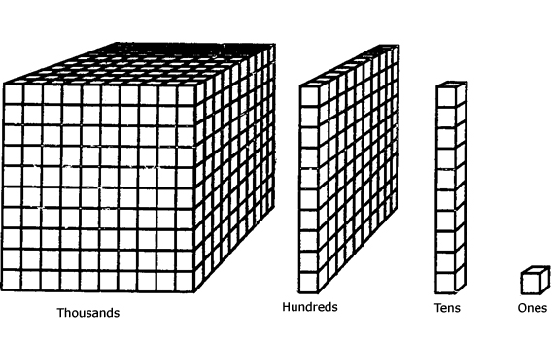
☐ A large collection of similar objects
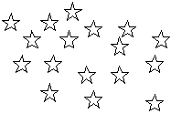

Penny is a Year 4 student who is attempting to use a subtraction algorithm. In the following example of her work, something is incorrect.

What would you do to help Penny understand how to use this algorithm?
 | WOULD NOT do | Might do | WOULD definitely do
Show her how to do the algorithm, then let Penny do another one.
Get her to use the algorithm to calculate 709 - 84.
Give her a calculator to check her answer.
Get her to calculate 797 - 84.
Use multibase arithmetic blocks (MAB) to demonstrate the process.
Suggest using an empty number line.

Which of the following explanations is least likely to be helpful in assisting a student who is struggling to understand that 1.26 is greater than 1.026?
☐ Multiplying both numbers by 1000 gives us 1260 and 1026.
1260 is greater than 1026 so 1.26 is greater than 1.026.

☐ 1.26 is 1 whole + 2 tenths + 6 hundredths
1.026 is 1 whole + 0 tenths + 2 hundredths + 6 thousandths

☐ It’s easier to compare decimals that are the same length and we can add zeros to the end of a decimal without changing it, so, 1.26 is the same as 1.260. We can now see that 1.26 is greater than 1.026 because 260 is greater than 026 (which is 26).

☐
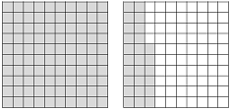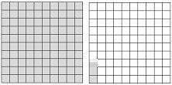
1.26 1.026

A 270 g packet of chocolate says “35% more chocolate for free”. What is the best way to use this with an upper primary class to develop their mathematical understanding?
☐ As a starter for a research project about the use of maths in advertising.
☐ I could get students to calculate 35% of 270 g.
☐ As a starter to discuss percentage increase.
☐ I wouldn’t use it – the numbers are too hard.

Section 6 is a block of 17 questions that appear in random order. Not all questions are presented in every survey instance.

A die has faces numbered 1 to 6. The die is biased so that the number 6 will appear more often than each of the other numbers. The numbers 1 to 5 are equally likely to occur. The die was rolled 1200 times and it was noted that the 6 appeared 450 times. Which statement is correct?
☐ The probability of rolling the number 5 is about one seventh.
☐ The number 6 is about twice as likely to occur as any other number.
☐ The number 6 is about three times as likely to occur as any other number.
☐ The probability of rolling an even number is about equal to the probability of rolling an odd number.

A partial drawing of a quadrilateral is shown in the diagram below. If no other sides or angles are congruent to the ones shown, which of the following best describes the figure?
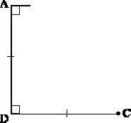

☐ square
☐ rectangle
☐ parallelogram
☐ trapezium

For each statement shown below, indicate whether it is True or False. | True | False

A signal at a pedestrian crossing near Sam’s house has the following cycle. It stays red for 30 seconds. It then changes to green for 20 seconds. What is the probability, to 2 decimal places, that it will be green the next time Sam wants to use this crossing?
☐ 0.00
☐ 0.20
☐ 0.40
☐ 0.50
☐ 0.67

A student has attempted to solve (x + 4)2 = 49 - x2. The student's solution is reproduced below.
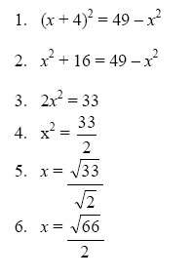
Look at each line of the student’s solution. Indicate whether each line is equivalent to the line above it.
☐ Line 2 is equivalent to Line 1
☐ Line 3 is equivalent to Line 2
☐ Line 4 is equivalent to Line 3
☐ Line 5 is equivalent to Line 4
☐ Line 6 is equivalent to Line 5

A student picks a value for x, and uses it in the function f(x) = 2x2 to get an answer. He then picks a new value for x, which is 3 times his original choice. His new answer is:
☐ 3 times his old one
☐ 6 times his old one
☐ 9 times his old one
☐ 18 times his old one
☐ 36 times his old one
☐ Can’t tell how the new answer relates to the old one

A tiler drew some patterns of white and coloured tiles to fill a square space and put the information in a table.
Side length of square space (Tiles) | Total number of white tiles
2 | 2
3 | 4
4 | 8
5 | 12
 |  | 250 | 1200 | 1250 | 2500
How many white tiles would be needed for a square space with a side length of 50 tiles?

A tortoise has been fitted with a GPS tracking device that reports that its speed is 0.87 km/h. The tortoise has been travelling at this steady speed for 350 m. Which of the following calculations (if any) would allow you to find out how long, in minutes, it has taken the tortoise to travel this distance?
 | Yes | No
0.87 x 350 x 60
0.87 x 0.35 x 60
0.87 ÷ 0.35 x 60
0.35 ÷ 0.87 x 60
350 ÷ 0.87 x (60 / 1000)
0.87 ÷ 350 x (60 / 1000)

Claire thinks of a number, n
She multiplies the number by itself.
She then halves that answer and subtracts 10.
Which expression shows what Claire did?
☐
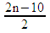

☐
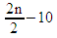

☐
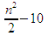

☐
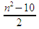

Here is the graph of a linear function.
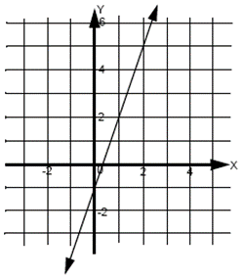
Which one of these points will lie on it?
☐ (-7, -5)
☐ (-5, -14)
☐ (6. 17)
☐ (8, 3)

In the following equations and inequalities, a and b are real numbers. Classify each as Never True, Sometimes True or Always True.
 | Never True | Sometimes True | Always True
a x b = b x a
a ÷ b = b ÷ a
5 + a > a
6 ÷ a > a
a² < a
a² +b² = (a + b)²
a – b = b - a

In a lottery in which 6 numbered balls are drawn from a collection numbered from 1 to 30, the probability of drawing the numbers 2, 11, 15, 16, 23, and 30 is:
☐ Less likely than drawing the numbers 1, 2, 3, 4, 5, and 6.
☐ The same as the probability of drawing the numbers 1, 2, 3, 4, 5, and 6.
☐ More likely than drawing the numbers 1, 2, 3, 4, 5, and 6.
☐ We would need to conduct a trial to be sure.

The diagram below is not drawn to scale. Angle ABE measures 30o and angle CED measures 110°.
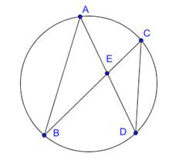
What additional information is necessary in order to find the size of angle ECD?
☐ Whether or not AB and CD are parallel.
☐ Whether or not triangle CED is isosceles.
☐ Whether or not E is the centre of the circle.
☐ No additional information is needed.

This diagram shows four measurements of a rhombus of side length b.
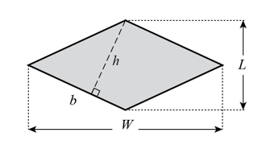
☐ 2hb = LW
☐ 2hW = Lb
☐ hb = 2LW
☐ hW = 2Lb

Two 6-sided dice are rolled, and the difference between the two numbers is calculated.
If the numbers shown are not the same, the difference between the two numbers is found by subtracting the smaller number from the larger number. If the rolled dice show identical numbers, the difference between the two numbers will be zero. Which of the following is the most likely difference?
☐ 0
☐ 1
☐ 2
☐ 3

 | 5.8m | 6m | 9m | 10.8m
An upright 1-metre stick casts a shadow that is 60 centimetres long. At the same time, a flagpole casts a shadow that is 5.4 metres long. How high is the flagpole?

When analysing her 50 scores for a video game, Jenni noticed that the mean score was substantially larger than the median score. What is the most likely reason for this to occur?
☐ Her scores have been gradually improving.
☐ There is an outlier score, much larger than most other scores.
☐ The mean of positive scores like these is usually larger than the median.
☐ The distribution of the scores is bi-modal.

Section 7 is a block of 15 questions that appear in random order. Not all questions are presented in every survey instance.

In introducing Pythagoras’ Theorem to a Year 9 class a preservice teacher conducted the following sequence of activities:
1. Asked students to draw squares on the sides of several right-angled triangles and explore the relationship between the square of the sides.
2. Gave the rule a² + b² = c² and asked students to memorise it.
3. Showed students how to calculate the hypotenuse of a right-angled triangle given the other two sides, using the following
two examples:
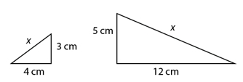

4. Gave students several questions in which they were asked to find the length of the hypotenuse of a right-angled triangle.

When providing feedback on the lesson the mentor teacher made the following comments. With which of them do you agree?
 | Agree | Disagree
Drawing squares on the sides of right-angled triangles wastes time as students will never be asked to prove Pythagoras’ Theorem.
Memorising the rule a2 + b2 = c2 is really important. Well done!
Your examples both worked out to be whole numbers. It is important to also give examples that yield irrational answers.
Just using questions where students have to find the hypotenuse is good as students would become confused if they were also asked questions where they had to find a short side.

A class was asked to calculate:
Jessica wrote the following on the whiteboard:
Of the following responses, which is the most appropriate?

☐ Remind Jessica that it is only necessary to find a common denominator when doing addition and subtraction.
☐ Let Jessica know that this method will work only sometimes and that to divide fractions she should instead invert the second fraction and then multiply.
☐ Explain that the twelves can be cancelled out only when there is one on the numerator and one on the denominator.
☐ Reassure Jessica that this procedure is acceptable, but ask Jessica to explain her thinking to other students.

A new calculator routinely provided some answers using exact arithmetic, such as:

Which of the following statements best describes the suitability of such a calculator for use in a secondary school?
☐ Unsuitable, as the answers shown are wrong.
☐ Unsuitable, as it is not yet approved by examination authorities.
☐ Unsuitable, as decimal answers are more helpful for practical calculations.
☐ Suitable, as it will provoke discussions about exact and approximate numbers.
☐ Suitable, as it will reduce demands on student algebraic and numerical skills.

Below is a student’s incorrect attempt to solve a pair of simultaneous equations:
3x - y = 7 (1)
x +y = 9 (2)
2x = -2
x = -1

Substitute into (2):
-1 + y = 9
y = 10

The student checks her solution via substitution into equation (1) and is surprised to see that it is does not make the equation true.
Which of the following statements gives the most likely explanation for the student’s error and the most appropriate next step for the teacher to take?

☐ The student has tried to subtract equation (2) from equation (1) but “cancelled” the –y and +y to eliminate this variable. The teacher should tell the student to add the equations instead.
☐ The student has tried to subtract equation (2) from equation (1) but “cancelled” the –y and +y to eliminate this variable. The teacher should ask the student to explain why she chose to subtract rather than add these equations.
☐ The student has tried to subtract equation (2) from equation (1) but “cancelled” the –y and +y to eliminate this variable. The teacher should suggest that the student use the substitution method instead, by finding an expression for x or y from equation (2) and substituting this into equation (1).
☐ The student has incorrectly added equations (1) and (2). The teacher should ask the student to repeat this addition, ensuring she does it correctly.

A Year 8 student wrote “This shape is a pushed over square”.
Which of the following would be the most appropriate feedback to give to students to develop their geometrical thinking?
☐ We call that shape a rhombus. Write the name in your book.
☐ That’s a great description. I like that you wrote a complete sentence.
☐ What if you turned it around so the point was downwards? Would it still be a pushed over square?
☐ Explain to me why it is like a square.

A teacher implemented the following activity from a lower secondary mathematics textbook to help students understand the formula for the circumference of a circle. Students worked in small groups to measure the diameters and circumferences of a set of circular objects. They used string to measure the circumferences and a ruler to measure the diameters. The class recorded their results on the whiteboard in the table below.
Object | Circumference (C) | Diameter (d) | c/d
Can of soup | 23.2 cm | 7.5 cm | 3.09
Egg ring | 24.3 cm | 7.5 cm | 3.24
Biscuit cutter | 18.7 cm | 6.0 cm | 3.12
Egg cup | 14.4 cm | 4.4 cm | 3.27
Pie dish | 40.2 cm | 12.6 cm | 3.19
One student then remarked that the C/d ratios were all different. What explanation or further activity should the teacher provide to ensure that students understand the purpose of this task?

☐ Engage the class in a discussion of measurement errors and ask them to measure some more circular objects and this time calculate the c/d ratios for them.
☐ Explain the ratios are so similar that we can assume a pattern of C/d = some constant, which we call “pi”. Tell students that the accepted value of pi is about 3.14, and their measurements and calculations were close to this value.
☐ Point out that the results suggest a pattern that we could investigate further by drawing a graph of circumference versus diameter.
☐ Provide the formula C = π x d and demonstrate how it can be used to calculate the circumference of a circle if we know the diameter.

Students were asked to respond to the following question:
A box contains 18 red jubes, 10 green jubes, 10 yellow jubes and 2 black jubes. Without looking, Sheryl takes a jube from the box. What is the chance that the jube is green?

One student says that the chance is 1 in 4. To help interpret this response, which of the following is the most appropriate question to ask next?

☐ It's not clear what they think, so I'd ask them a similar question, but with only 8 red jubes instead of 18 red jubes.
☐ It's not clear what they think, so I'd ask them a similar question with smaller numbers such as: 10 red jubes, 5 green jubes, 4 yellow jubes and 1 black jube.
☐ It's not clear what they think, so I'd ask them a similar question with smaller numbers and fewer categories such as: 7 red jubes, 5 green jubes, and 3 yellow jubes.
☐ Since the student has responded correctly, it is not necessary to do anything more.

The expansion of (3x + 1)(x + 2) relies on use of the distributive law.
Which of the following representations of (3x + 1)(x + 2) best illustrates how the distributive law is used in this expansion?
☐ FOIL (First, Outside, Inside, Last)
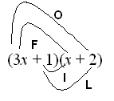

☐ Show the expansion as a long multiplication
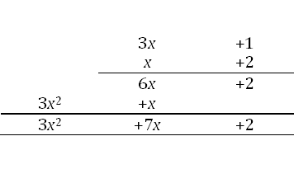
☐ Substitute numbers to show that the expansion is correct.

(3x + 1) (x + 2) = (3 ×7 + 1) (7 + 2) = 22 × 9 = 198
3(x²) + 7x + 2 = 3(7²) + 7(7) + 2 = 147 + 49 + 2 = 198

☐ Use an area diagram:
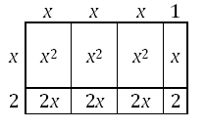

The following is a part of a set of cards for students to sort:
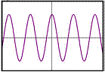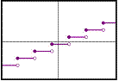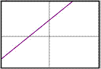
If the purpose of the cards is to help students to understand the definition of ‘function’, which of the following would be the most useful addition to the set?
☐
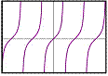

☐
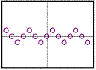

☐
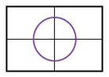

☐
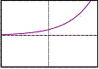

The following question was given to Year 8 students:
Some children are making batches of cordial by mixing together sweet concentrate and water.
Sally uses 4 cups of sweet concentrate and 13 cups of water.
Myles uses 6 cups of sweet concentrate and 15 cups of water.

One student has a misconception and thinks these cordial mixes will have the same sweetness.

Which of the following cordial mixes might this student ALSO think will have the same sweetness?
☐ Aisha uses 8 cups of sweet cordial mix and 26 cups of water.
☐ Carly uses 10 cups of sweet cordial mix and 19 cups of water.
☐ Deng uses 8 cups of sweet cordial mix and 20 cups of water.
☐ Erin uses 10 cups of sweet cordial mix and 28 cups of water.

This diagram represents the number of people that can be seated as small tables are added.

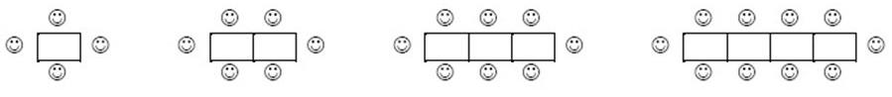
Students were asked to find a rule to link the number of tables used and the number of people who could be seated, and express this algebraically using T for the number of tables and P for the number of people.

Three students’ answers were: P = 2T + 2 P = (T – 2) x 2 + 6 P = 2(T + 1)

What representation could you best use to convince them that these solutions are the same?
☐ Work through the algebra on the board.
☐ Create a table of values for each rule and compare them.
☐ Draw a graph for each rule on the same axes.
☐ Get them to try a different problem with the same relationship.

You are about to begin investigating index laws with a Year 7/8 class.
Choose the best approach for teaching the following:
a^{m} x a^{n} = a^{m+n}
a^{m} ÷ a^{n} = a^{m-n}
(a^{m})^{n} = a^{mn}

☐ Provide the rules, demonstrate 3 examples, and ask the students to complete some exercises.
☐ Write the rules, begin with numerals, such as Base 10, then move to algebraic problems.
☐ Provide examples where the students search for patterns and develop each of the rules.
☐ Ask the students to work at their own pace through the text-book exercises. Students seek help when necessary.

This is a student's response to a test question:
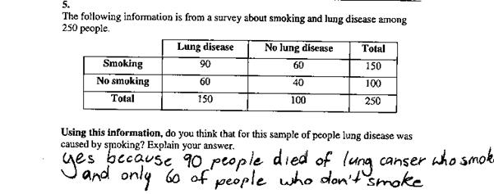
Indicate which of the following statements is a reasonable inference concerning this student's thinking.
☐ The student has considered only one column in the data table.
☐ The student has considered only one row in the data table.
☐ The student has been influenced by prior knowledge of issues concerning smoking and lung disease.
☐ The student may need further assistance to develop proportional reasoning.

Which of the following explanations is least likely to be helpful in assisting a student who is struggling to understand that 1.26 is greater than 1.026?
☐ Multiplying both numbers by 1000 gives us 1260 and 1026.
1260 is greater than 1026 so 1.26 is greater than 1.026.

☐ 1.26 is 1 whole + 2 tenths + 6 hundredths
1.026 is 1 whole + 0 tenths + 2 hundredths + 6 thousandths

☐ It’s easier to compare decimals that are the same length and we can add zeros to the end of a decimal without changing it, so, 1.26 is the same as 1.260. We can now see that 1.26 is greater than 1.026 because 260 is greater than 026 (which is 26).

☐
1.26 1.026

Section 8 contains just this one question:

Do you have any other comments about your beliefs, content knowledge or pedagogical knowledge regarding the teaching of mathematics?

